Tips for sanitising gaming machines

With some light at the end of the tunnel regarding the re-opening of your gaming rooms, we’ve put together some best practice tips regarding cleaning your gaming machines (EGMs) to protect the health of your patrons, personnel and the machines themselves.

Most EGMs feature touch screens and button panels, so the choice and method of applying any cleaning agent is very important. Touchscreens are sensitive to liquid sprays, particularly those that are ammonia-based, so some cleaning agents may affect the touch-sensitive coating on these screens.

So, be careful in choosing your sanitising solution and consider the following:

- Don’t spray directly onto touch screens – spray a cleaning agent into a clean non-abrasive cloth and then wipe the touch screen
- For a disinfectant to be effective, the solution may need to remain wet for a specific timeframe – refer to your cleaning solution recommendations for this.
- Once air dry, use a microfibre cloth to remove streaks from the touchscreens
- Glass cleaner (with no ammonia/vinegar) can be used to remove stubborn streaks
- Disinfecting wipes can also be used, remembering not to allow any additional liquid to pool on the touch screen.

The above cleaning pointers can also be applied to other surfaces on an EGM – remembering that it is very important not to allow disinfectants to pool on screens or penetrate creases and openings. In relation to EGM plastics, it is best to test an inconspicuous area first. If there is no visible reaction or discolouration then you can clean the entire EGM.

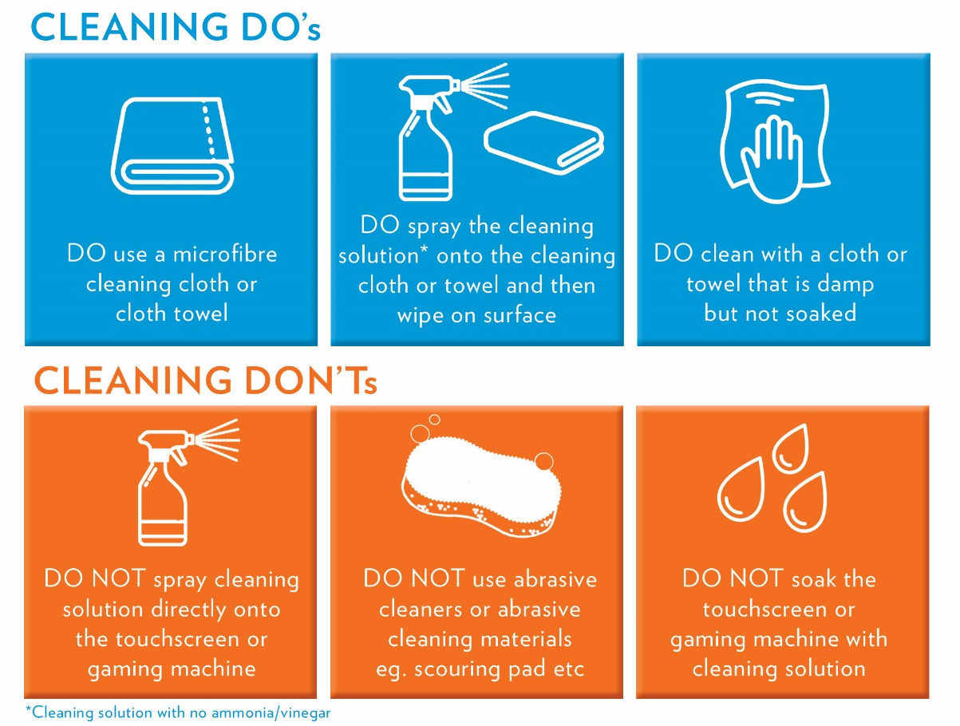

The Australian Government Department of Health has not mandated any specific cleaning products but does have a number of information resources available in relation to cleaning and disinfection principles for COVID-19. For one example click here.

